SUBCUTANEOUS INSULIN
Insulin orders generally* have three components:

BASAL – Controls fasting and pre-meal glucoses
- NPH or Lantus® (glargine) given daily or twice daily
- Dose may be reduced but never held in patients with type 1 diabetes
- If NPO for a procedure
  - Day prior to procedure take usual doses in morning and evening
  - Morning of procedure take 50% of basal insulin
- If NPO for an extended period of time
  - NPH or Lantus® should be given but verify dose(s) with House Officer.
NUTRITIONAL – Covers nutrition (meals or tube feedings)
- Discrete meals: use Novolog® (aspart) three times daily with meals
- Tube feedings: use regular every 6 hours
- Hold if NPO or if tube feedings stopped
- Give even when glucose is normal as long as patient is eating or tube feedings are running
CORRECTIONAL (SLIDING SCALE) – Covers unexpected hyperglycemia
- Use same type and at same time as nutritional insulin
  - Discrete meals: use Novolog® (aspart) before meals and nightly
- Tube feedings, NPO, or parenteral nutrition: use regular every 6 hours
- Give as needed even if NPO or if tube feedings or parenteral nutrition turned off

* These are guidelines. Actual orders may vary. Always give insulin as ordered.
For questions or comments, please contact the Diabetes Management Service [insert pager]

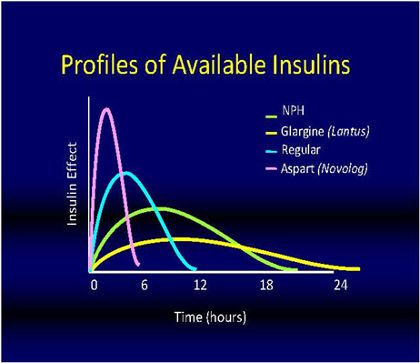
Frequently Asked Questions

Q: It is 12:30 PM and your patient is about to eat lunch. His blood glucose is 84 mg/dL. Do you give him the Novolog® 4 units q AC that he is ordered?
A: Yes. The Novolog® 4 units q AC is nutritional insulin that should be given as long as the patient is going to eat the meal.

Q: It is 8 AM and your patient with type 2 diabetes mellitus is NPO for a colonoscopy. His order is for NPH 15 units q AM. What would you give?
A: You would check with the house officer for an order to give ½ of the morning NPH dose on the day of a procedure unless otherwise specified.

Q: It is 2:30 PM and your patient is about to eat lunch. His last blood glucose was at 12 PM and the result was 205 mg/dL. His order is for Novolog® 5 units q AC and Novolog® sliding scale. What do you do?
A: Recheck blood glucose to obtain a value right before he eats his meal and give Novolog® 5 units as well as any sliding scale coverage needed, based on the recent bedside BG.

Q: It is 8 AM and your patient is NPO for surgery later today. His blood sugar was 225 mg/dL. His order is for Novolog® 6 units q AC and Novolog® sliding scale (medium) q AC + nightly. Should you give any insulin?
A: Yes. Patient may receive correctional insulin (Novolog® sliding scale) but not nutritional insulin (Novolog® 6 units) since he is not going to eat.

Q: Your patient with type 1 diabetes mellitus is NPO after midnight. He has an order for Lantus® 20 units at bedtime. Should you give the insulin? How much?
A: Yes. Patients with type 1 diabetes must always receive their basal insulin since they don’t make any insulin. You would give the full Lantus® dose.

Q: Your patient has ordered lunch but when the meal arrives he is complaining of poor appetite and you are unsure if he is going to eat. He has an order for Novolog® 5 units q AC and Novolog® sliding scale (low) q AC. His pre-meal BG is 200 mg/dL. What do you do?
A: It is okay to wait until immediately after the patient finishes his meal to give him his insulin, both nutritional (Novolog® 5 units) and correctional (Novolog® sliding scale).
For questions or comments, please page the Diabetes Management Service [insert pager number].

